 Site Amendments

Sleep analyser form - this is nicely set up but when you submit there is no page that acknowledges that you have completed the survey or what will happen next.

Home page: please change the ‘sign in’ button text to ‘login’ as we are using the words ‘login’

Home page: please remove the sheep sleep science logo from the far left corner.

Please change the login and sign up buttons to the same button type that you have used on the top left for ’19 sheep’ and ‘dream analysis’ this will make the homepage look cleaner.

Please remove the orange horizontal line from the top of the page - it’s not necessary. Perhaps just change the colour of it to white. Feel free to keep the triangle button slider though that is just above it as it looks nice.

Sign up page: please remove words ‘hello provide your email’

Sign up page: please remove words ‘email’ ‘password’ and ‘password’ from above the input boxes. It looks like an unnecessary repetition because we have the same text inside the boxes. Please change the text inside the 3rd input box to ‘Confirm Password’.

Please remove the solid fill colour from the reset and submit buttons.

Login page: please adjust as follows. Please remove the solid fill colour from the log in button.

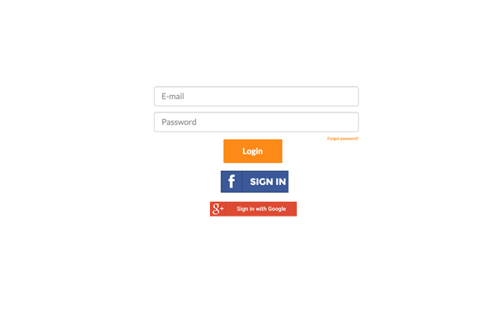

Sign Up

Sign up presently does not allow for the input of decimal values for height and weight.

For height it wanted either 1 or 2 metres

For weight it woudn’t accept 83.5 Kg

Present Dashboard

My activity score seems to be working but not my sleep score.

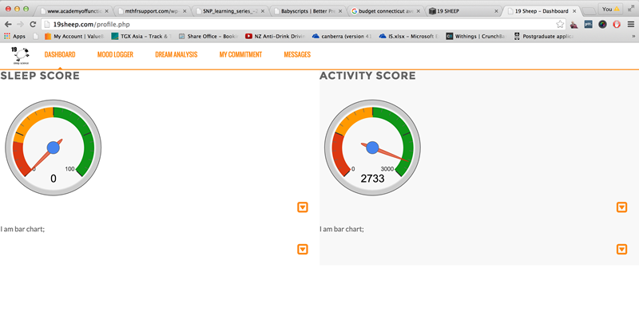

Please adjust as follows

Change BG of activity area to white.

Change colour of orange horizontal line to white

Reposition sleep and activity score columns to the right so level with menu.

We need to have a consistent menu at the top - it keeps changing depending what page we are in.

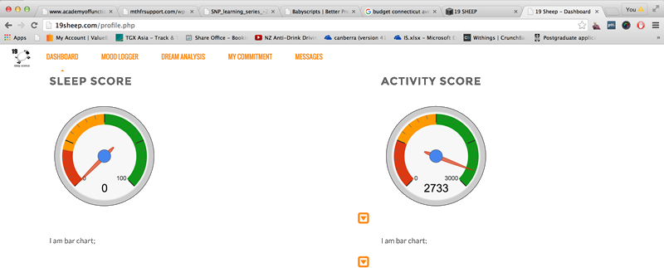

Dream form

Please remove the reset button.

Please shift the submit button to the left and remove the solid green colour from the button.

Please add a check box next to the submit button - I would like 19 sheep to assist me interpreting this dream.

Add another button ‘Log another dream’.

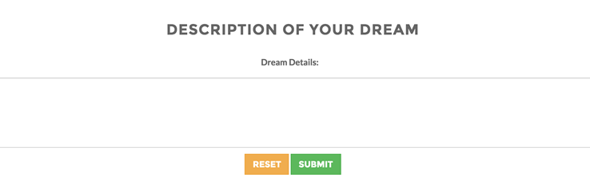

Dream form

Please remove the reset button.

Please add a button make another commitment

Please remove the solid colour from both of the buttons.

Please remove text ‘Provide more detail’.

Please remove the grey box border.

I couldn’t get the commitment form to work.

